Methodology and Data Analysis and Interpretation of Cane Juice Centrifugation
Author Name
Affiliation
Email
Abstract:
The determination of rotator for the particular sort of suspension needs some fundamental information. The particles, which are available in various sizes, their appropriation in the medium, unique thickness, thickness and so on are the fundamental rules. It consists of a critical screw type conveyor which removes the deposited solids. The speed keeps up could be around 8000 rpm in the scope of 70-75% mud moisture. In this paper we are discussing centrifugation of cane juice in the sugar industry.
Keywords: Cane juice, Centrifugation, ICUMSA, viscosity etc.

- INTRODUCTION
Centrifugation is one of the paramount unit operations in the sugar industry. The separation of suspended particles and organic salts at a primary stage and at an ambient temperature (at the cold stage) has an advantageous impact on clarification. Otherwise, at a higher temperature the dissolution of suspended particles is more likely to take place. In the latter case, the separation will be more difficult and will increase the scale deposition in a heat exchanger as well as increase the viscosity. This reduction of mud will also reduce the volume of mud normally obtained from the clarifier, which is around 25% on cane. As such, the load on the vacuum rotary filter will be reduced by 5-7%. The filterability of centrifuged mud/juice may pose a problem in the absence of suspended particles. the physical appearance of the treated juice is quite brilliant with a tinge of turbidity containing a small amount of floating bagacillo. A very similar greenish tinge was also reported by Hionig, whilst the colour measurement shows a remarkable improvement due to centrifugation. In Indian conditions, the dirt correction plays an important factor in the analysis of the sugar balance. Instead of the conventional method, if the centrifuged juice is directly weighed, the sugar balance report could be made more accurate. This is an additional advantage of the treatment.
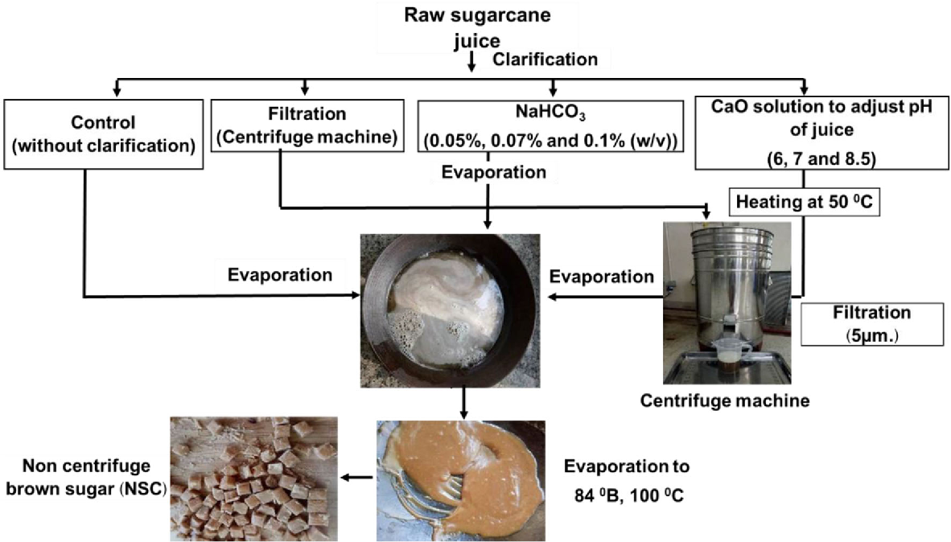

Fig 1: cane juice centrifugation

II. MATERIALS AND METHODOLOGY

Cane juice samples were subjected to centrifugation using a Remi R-8 C batch-type laboratory model. This was operated at 6000 rpm, attaining 2000g at the bottle tip. For every run it was set for 5 minutes. Optimization of the centrifuge operation is a function of design and so was not carried out. Only the various effective parameters due to centrifugation of cane juice have been observed in the present study. Purity measurement of cane juice was done using a Sucromat in a conventional way. A Brookfield RVT viscometer was used to measure the apparent viscosity difference at 50 rpm using spindle No.1 The ICUMSA colour measurement was done using TEA-buffer and membrane filter as described elsewhere. The colour measurements were carried out on an ELICO spectrophotometer.

III. DATA ANALYSIS AND INTERPRETATION
TABLE I

MEDIUM | WET MUD % | MOISTURE | CHEMICAL LOAD MILK OF LIME | ASH % ON CANE | ASH % ON
 | W/W |  | SO2 | JUICE | MUD
CANE JUICE | - | - | 11.8CC X | - | -
TREATED  JUICE | 5.2 | 75.7 | 12.5CC X | 0.12 | 11.5

TABLE II

MEDIUM | VISCOSITY CPS | CLARITY | ICUMSA UNITS
CANE JUICE | 1.25 | 42.8 | 4220.00
TREATED JUICE | 1.18 | 13.5 | 3294.00
CLEAR JUICE | 1.02 | 11.8 | 2815.00

- CONCLUSION
The study involves the centrifugation of cane juice. The juice is subjected to centrifugation directly after milling of the cane. This treatment has been thought of particularly to clarify juices by removing the suspended particles, viz. silica, organic salts, etc. along with mud. In this paper the design pattern of the centrifuge has been shown. The effective factors such as removal of suspended particles, clarity and ICUMSA colour of the centrifuged juice has shown by the table and graph.

REFERENCES
[1] Premalatha M (2008) Efficient cogeneration scheme for sugar industry. Journal of Scientific & Industrial Research 67:239-242
[2] Birru (2007) Investigation of the potential of sugar cane industries (MSc thesis)
[3] Marianela Cordovés Herrera(1999).“CaneSugar and The environment-Cuba conference”. Available at http://www.fao.org/docrep/005/X4988E/x4988e01.htm. Accessed March 2012
[4] Ingaramo A, Heluane H, Colombo M, Cesca M (2009) Water and wastewater eco-efficiency indicators for the sugar cane industry.Journal of Cleaner Production 17 : 487–495
[5] Kamate CS and Gangavati BP (2009) Cogeneration in Sugar Industries: Technology Options and Performance Parameters—A Review, Cogeneration & Distributed Generation Journal, 24:4, 6-33, DOI:10.1080/15453660909595148
[6] Raghu RJ, Banerjee R(2003)Energy and cogeneration targeting for a sugar factory. Applied Thermal Engineering 23:1567–1575
[7] Ensinas VA, Lozano MA, Serra LM (2007) Analysis of process steam demand reduction and electricity generation in sugar and ethanol production from sugarcane. Energy conversion & Management 48:2978-2987
[8] Lavarack BP, Hodgson JJ, Broadfoot R, Vigh,S and Venning J (2004) Improving the energy efficiency of sugar factories: Case study for pioneer mill Proc. Aust. Soc. Sugar Cane Technology: 26
[9] ABB (2010) ACS 1000 variable speed drives increase energy efficiency at sugar plant-case study. Available at: http://www05.abb.com/global/scot/scot216.nsf/veritydisplay/46ae6cf38fa1228bc12577e40056e21d/$file/CS_Sugar%20RevB_lowres.pdf
[10] Dias SOM, Modesto M, Ensinas VA, Nebra AS, Filho MR, Rossell VEC (2011) Improving bioethanol production from sugarcane: evaluation of distillation, thermal integration and cogeneration systems. Energy 36:6, 3691–3703
[11] Solomon S (2011) The Indian Sugar Industry: An Overview. Sugar Technology 13(4):255–265
[12] Keerthipala RA (2007) Sugar Industry of Sri Lanka: Major Issues and Future Directions for Development. Sugar Technology :9(1) 1-10
[13] Ethiopian sugar corporation. Available at http://www.etsugar.gov.et/
[14] Alonso-Pippo W, Luengo AC, Koehlinger J, Garzone P, Cornacchia G (2008) Sugarcane energy use- The Cuban case. Energy Policy 36 : 2163– 2181
[15] Edward D (1981)Standard Fabrication Practices for Cane Sugar Mills. Amsterdam: Elsevier Scientific Pub. Co. ; New York: Elsevier Scientific Pub. Co. ; New York: Elsevier Scientific Pub. Co. ISBN0-444-41958-6;ISBN1-322-26407-4;ISBN1-4832-8967-2
[16] Costa, A. F. S.; Nascimento, V. R.; Amorim, J. D. P.; Gomes, E. A. S.; Araujo, L. M.; Sarubbo, L. A. Residue from the production of sugar cane: an alternative nutrient used in biocellulose production by Gluconacetobacter hansenii. Chemical Engineering Transactions, v. 64, p. 7-12, 2018. DOI: 10.3303/CET1864002
[17] Hamerski, F. Study of variables in the process of carbonation of the broth of sugar cane. p. 148. Dissertation. Graduate degree in food technology. Federal University the Paraná, Curitiba, 2009.
[18] Alemu Aderu; 2009; “Energy assessment, energy utilization & generation efficiency (a case study in Finchaa sugar factory)”,MSc thesis

